Themenblock 5: Health & Fitness

CATEGORY A: CONTRASTING IMAGES

TASK SET A1: Traditional vs. Digital Fitness

Part 1 — Individual Long Turn

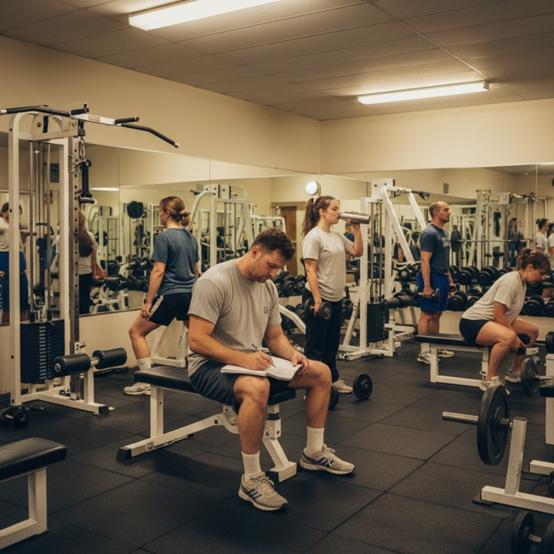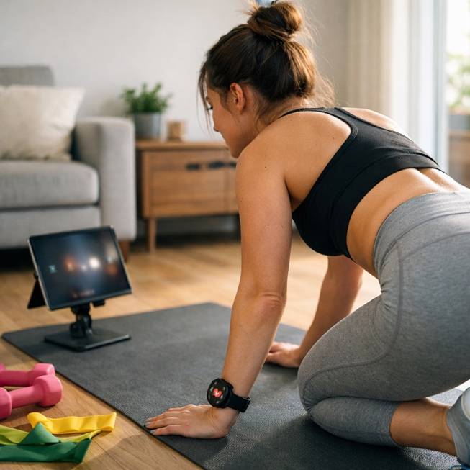

Give a five-minute talk on fitness and technology in which you
- Describe, compare and contrast the pictures above.
- Analyze how technology has changed the way people approach fitness and exercise.
- Discuss the advantages and disadvantages of using fitness apps and wearable technology.

Part 2 — Paired Activity
Your school is organizing a "Fitness Week" to promote healthy lifestyles among students. You and your partner have been asked to plan the program.
Discuss the following activities and agree on THREE to include:
- Morning yoga or stretching sessions before classes
- Fitness app workshop showing students how to use health technology
- After-school group workout challenges (teams compete for most steps)
- Guest speaker from a local gym or fitness influencer
- "Digital detox" walk in nature without phones

TASK SET A2: Indoor vs. Outdoor Exercise

Part 1 — Individual Long Turn



Give a five-minute talk on exercise environments in which you
- Describe, compare and contrast the pictures above.
- Evaluate the benefits of exercising indoors versus outdoors for physical and mental health.
- Comment on your personal preferences and experiences with different exercise settings.

Part 2 — Paired Activity
Your local council is debating whether to invest in a new indoor sports center or improve outdoor exercise facilities in parks. You and your partner have been invited to present arguments for each side.
Take opposing positions (one supports indoor facilities, one supports outdoor) and discuss these aspects:
- Weather independence and year-round accessibility
- Mental health benefits and connection with nature
- Cost of construction and ongoing maintenance
- Social interaction and community building
- Safety and supervision concerns
Come to a joint recommendation for the council.

TASK SET A3: Stress and Mental Wellbeing

Part 1 — Individual Long Turn



Give a five-minute talk on stress and mental health in which you
- Describe, compare and contrast the pictures above.
- Analyze the causes and effects of stress among young people today.
- Outline strategies that schools and individuals can use to promote better mental health.

Part 2 — Paired Activity
Your school wants to introduce a "Mental Health Day" where regular classes are replaced with wellbeing activities. You need to decide on the program together.
Discuss the following activities and agree on THREE to include:
- Guided meditation and breathing exercises
- Art therapy workshop (painting, drawing, creative expression)
- Peer support circles where students share experiences
- Visit from therapy animals (dogs, cats)
- Outdoor nature walk with no phones allowed

CATEGORY B: QUOTES

TASK SET B1: Mental and Physical Health Connection

Part 1 — Individual Long Turn
Quote 1:
"There is no health without mental health."
— World Health Organization
Quote 2:
"A child's mental health is just as important as their physical health and deserves the same quality of support."
— Catherine, Princess of Wales (2015)
Task:
Give a five-minute talk on mental and physical health in which you
- Analyze and compare the two quotes above and discuss what each suggests about health.
- Evaluate whether mental health receives the same attention as physical health in society.
- Comment on what young people can do for mental and physical wellbeing.

PART 2 — Paired Activity
Task:
Your class is creating an awareness campaign called "Healthy Mind, Healthy Body" for the school community. Discuss the following topics and agree on THREE to include:
- Understanding anxiety and depression: signs, causes, and support
- Sleep hygiene: why sleep matters and how to improve it
- Nutrition and mood: how diet affects mental wellbeing
- Digital wellbeing: managing screen time and social media
- Physical activity and mental health: the exercise-mood connection

TASK SET B2: Prevention vs. Cure
PART 1 — Individual Long Turn
Quote 1:
"Prevention is better than cure."
— Desiderius Erasmus (Dutch philosopher, c. 1500)
Quote 2:
"The doctor of the future will give no medicine but will instruct his patient in the care of the human frame, in diet, and in the cause and prevention of disease."
— Thomas Edison (American inventor, 1903)
Task:
Give a five-minute talk on preventive healthcare in which you
- analyze and compare the two quotes above and what they suggest about healthcare.
- discuss why prevention is often neglected in favor of treatment in modern healthcare.
- outline practical ways young people can prevent health problems through lifestyle choices.
PART 2 — Paired Activity
Task:
A health insurance company wants to launch a campaign encouraging young people to adopt healthier lifestyles. Discuss the following campaign ideas and agree on THREE to recommend:
- "Know Your Numbers" — free health screenings at schools (blood pressure, BMI)
- "Cook It Yourself" challenge — social media campaign promoting home cooking
- Rewards program for hitting fitness goals (discounts, prizes)
- Educational podcasts/videos featuring young health influencers
- "Sleep Challenge" — 30 days of tracking and improving sleep habits

CATEGORY C: ALTERNATIVE PROMPTS

TASK SET C1: Teen Sleep Deprivation Crisis

Part 1 — Individual Long Turn

Text Extract
THE SLEEP CRISIS AFFECTING TEENAGERS
Teenagers need between 8-10 hours of sleep per night, yet studies show that close to 70% of teens don't get enough sleep. Research across 24 European countries found that only 32-86% of adolescents meet sleep recommendations on school days. Sleep deprivation has been linked to increased anxiety and depression, poor academic performance, and higher risk-taking behaviors. The American Academy of Pediatrics has called teenage sleep deprivation a "public health epidemic."
Sources: Child Mind Institute (2024), Journal of Adolescent Health (2020)

Give a five-minute talk on teenage sleep in which you
- Explain the significance of the statistics presented and discuss why they are concerning.
- Analyze the factors that prevent teenagers from getting enough sleep.
- Discuss changes at home, school, and societal levels to improve teen sleep.

PART 2 — Paired Activity
Task:
You have been invited to present to the school board, who are considering changing the school start time from 8:00 AM to 9:00 AM to improve student sleep. Discuss these topics and agree on THREE to focus on:
- Impact on student health and academic performance
- Logistical challenges (bus schedules, parent work times)
- Effect on after-school activities and jobs
- Potential resistance from teachers and staff
- Evidence from schools that have already made this change

TASK SET C2: The Fitness App Revolution

Part 1 — Individual Long Turn

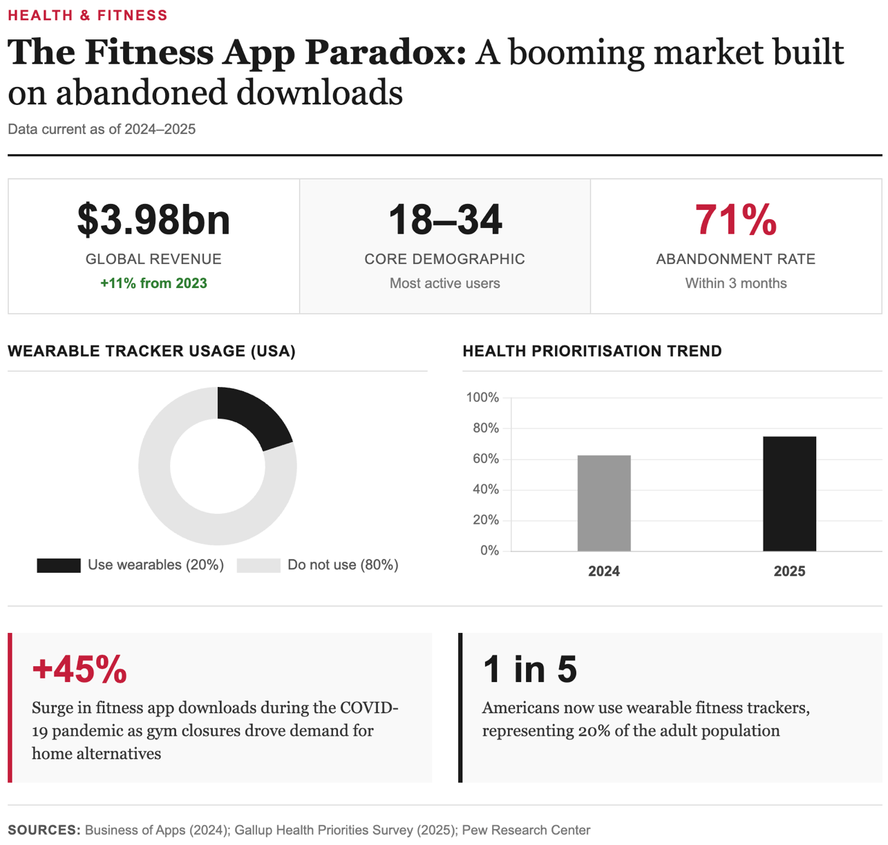
Task:
Give a five-minute talk on fitness technology in which you
- analyze the key trends shown in these statistics.
- discuss why so many people abandon fitness apps.
- evaluate whether these apps genuinely help people become healthier.
PART 2 — Paired Activity
Task:
You are working as consultants for a tech startup that wants to create a fitness app specifically for teenagers. Discuss the following potential features and agree on THREE priorities:
- Social challenges: compete with friends on step counts and workout streaks
- AI personal trainer: customized workout recommendations based on goals
- Mental wellness integration: meditation, mood tracking, stress monitoring
- Gamification: earn badges, unlock levels, virtual rewards
- Privacy-first design: no data sharing, anonymous usage option

